23 Garrison’s Landing, Garrison, NY 10524
845-424-3960 garrisonartcenter.org

FOR IMMEDIATE RELEASE
Tony Moore: Eternal Becoming
April 8 – May 7, 2023
Opening Reception: Saturday, April 8, 5 - 7 pm
Artist Talk: April 23, 2 - 4 pm
Contact: Kate Cahill, Exhibitions Coordinator, gallery@garrisonartcenter.org

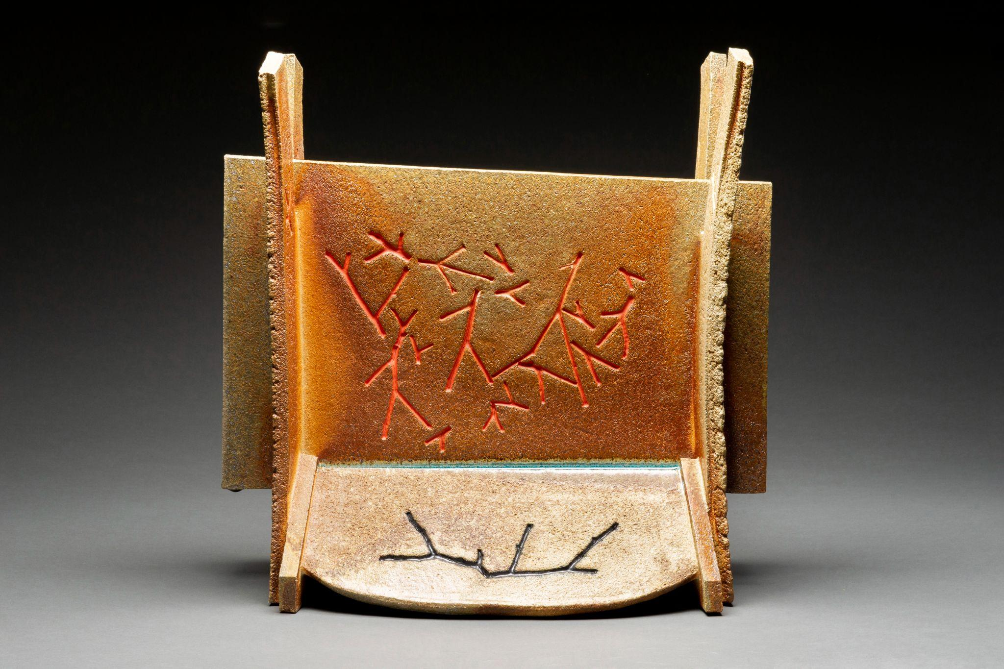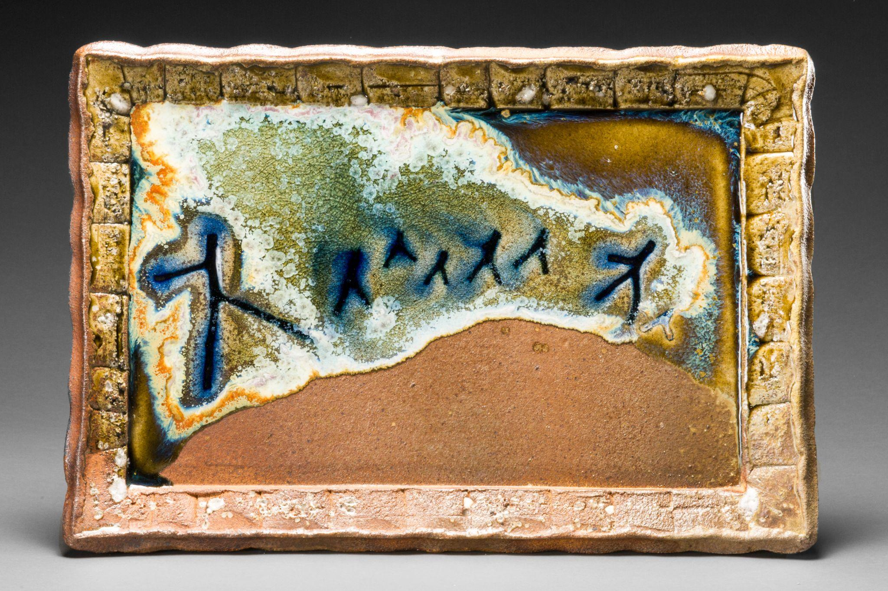
LEFT: All Together, 2022, 21¾” x 22½” x 10”, wood-fire ceramic, slip, glass
RIGHT: Fire Painting 2.11.18, 2018, 15” x 22.5” x 2.5”, wood-fired ceramic, glass, olive celadon, slip, stone inclusions

March 5, 2023, Garrison, NY - Garrison Art Center (GAC) is pleased to announce Eternal Becoming, an exhibition of ceramic sculptures and Fire Paintings by Tony Moore. A member for 25 years, this is the artist’s first solo show at GAC. Eternal Becoming will run from April 8 - May 7 with an opening reception on Saturday, April 8th, from 5 - 7 pm.

“My work is concerned with the relationship of humanity and nature," said Tony Moore. “I conceive of an expanded concept of ‘Nature’ as embodying all existence, both the seen, and unseen, socio-political events, daily occurrences, as well as private intuitions that are made concrete through creative action. My objects are places of remembrance where multiplicities of associations take place. Most recently these have been concerned with issues of the human condition.”

Moore continues, “In recent ceramic sculptures, and Fire Paintings, abstracted figures -- made from cut twigs -- are impressed into wet clay. As I investigated, the figures kept running, fleeing, tumbling, searching, moving away from, and towards something else. They moved across landscapes, towards glowing edifices, and systemized structures, which both beckoned them, and somehow dominated them. The figures were present, yet also in spirit form, floating and dissolving in diaphanous light, and shimmering waters. Twigs became fathers, mothers, and children. They became surrogates, rather like small children’s dolls, playing out a deeply psychological fiction of desperately searching for ‘something’. Something hopeful, yet presently out of reach. Something eternally becoming …”

-more-
Within the context of current issues such as migration, global pandemic, and now the Russian-Ukraine war, these abstracted works evoke both contemporary anxieties, and aspirations toward the future.

An English-American sculptor, and painter, Tony Moore is represented in international museum collections including the Guggenheim Museum, Brooklyn Museum, Greenville Museum, San Angelo Museum of Fine Arts, Woodstock Artists Association & Museum, Art Museum of the U. of Memphis and ASU Art Museum, US, and the Yorkshire Museum and Derby Museum, UK.

He received an MFA in Sculpture from Yale University, and is the recipient of prestigious awards, including a Louis Comfort Tiffany Award, CAPS Grant and Sally and Milton Avery Fellowship.

In 1998, after 25 years of making sculptures, and paintings in New York City, Moore relocated his home and studio to the scenic Hudson River Valley near Cold Spring, NY where on a mountaintop property, he built a spacious studio, gallery, and Japanese style Anagama-Noborigama wood-fire kiln. His unique ceramic sculptures are fired in the kiln four times a year during weeklong communal events.

Eternal Becoming will be on view in the Gillette Gallery, concurrent with This Happened, an exhibition by Sandy Moore in the Balter Gallery. The Galleries at Garrison Art Center are open Tuesday – Friday, Sunday, 10 - 5 pm and Saturday 12 - 5 pm.

For Additional Information
To learn more about Tony Moore, visit www.tonymooreart.com. For information about exhibitions, classes, and other programs at the Garrison Art Center, please visit garrisonartcenter.org or call 845.424.3960. Join the conversation via Instagram @GarrisonArtCenter.

About The Garrison Art Center
The Garrison Art Center (GAC), located in Garrison, NY, is a 501 (c) (3) not-for-profit arts and education organization founded in 1964. GAC is committed to making a difference by providing access to the visual arts to a diverse audience of learners, professional artists, community members, collectors, families, and friends from varied ethnic, cultural, geographic and economic backgrounds.
###

